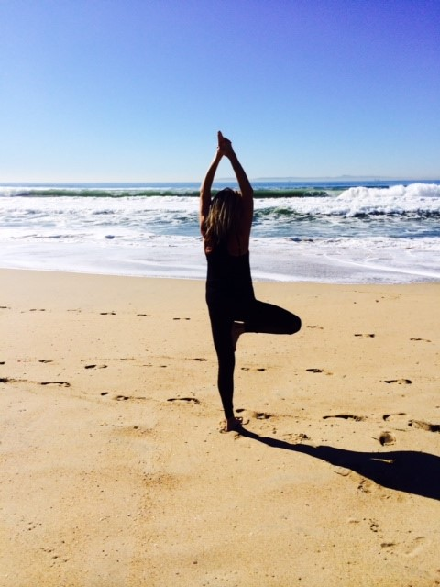

**Dress: Swimsuits, Water Shoes, Sunscreen!**

**Let’s have some fun and GET FIT!**

**Contact: Sandy Tricamo**

**314-791-7714 or** [**sandytricamo@sbcglobal.net**](mailto:sandytricamo@sbcglobal.net)

**See you at the Pool!**

**When: Monday June 5th thru August 7th**

**Time: 8:00AM to 8:45AM**

**No Reservations Needed!**

Sandra A. Tricamo